Timing Is Everything
A batter has little time to react to a pitcher’s throw. In this activity we compare the limits of human reaction time to the time it takes for a ball to go from the mound to the plate.

Some Background

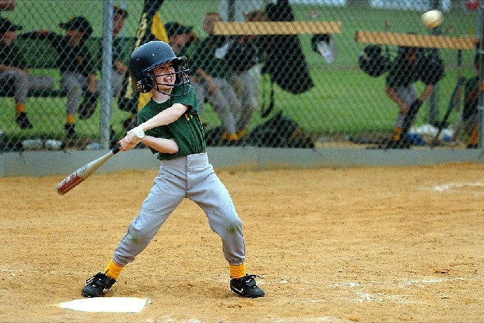
A major league fastball can travel to the plate at a speed of 90 mph, or 132 feet/sec. The distance between the pitcher’s rubber in the center of mound and the batter is just over 60 feet (60ft 6in). This means that the ball travels from the pitcher’s hand to the bat in

Time = distance/velocity = 60 ft ÷ 132 ft/sec = 0.45 sec

The ball travels about a dozen feet before the batter has a good visual fix on it. The batter now decides what kind of pitch it is, how fast it is going, and where it’s going. Now the batter has about 0.3 seconds to swing. Is it possible to react this fast? Is human reaction time quick enough? Let’s find out.

Materials Needed (for each group of 8-10 students)

• “Circle of Nerves” activity (from the “Human Body Explorer” by Karen Kalumuck and the Exploratorium)
• A timer
• A metric tape measure

To Do And Notice

• Divide the class into 3 research groups. Each research group will be responsible for measuring human reaction time. See “Circle of Nerves” activity for instructions.

• Each group should report on what they found to be the time for one person to pass the hand squeeze from one hand to the next.

• When a batter swings, a nerve signal has to travel from the brain to the hands. Using what you learned from doing “Circle of Nerves,” estimate how long it takes for the electrical signal to go from the visual cortex to the hands. Given that a fastball pitch will take about 0.3 sec to reach the plate from the point the batter has figured out what kind of pitch was thrown, will that be within human reaction time?

What’s Going On? (from www.exploratorium.edu/baseball)

When one nerve cell signals another, it does so by releasing a chemical substance that crosses a tiny gap between the cells, called the "synapse." It takes about half a thousandth of a second for the chemical transmitter to flow across the gap, a period called "synaptic delay."

The longest delays probably involve the nerve cells that make the decision to swing. These decision-making cells receive their input from the eye by way of the brain's visual cortex. It takes at least 0.04 seconds for information about the velocity and trajectory of the baseball to be sent from the retina to the higher visual cortex. What happens during the actual "decision" is a neurological mystery - -but once the decision is made, a signal is sent to the cerebellum initiating a series of pre-programmed, reflex-like actions (for a practiced batter).

Moving a single group of muscles may require the interaction of numerous nerve cells and involve multiple synaptic delays, as the body receives sensory information (sees the ball), processes it (makes a decision), and coordinates muscle action (swings the bat). Practice eliminates wasted time by speeding up the decision-making -- somehow the obvious mistakes and fruitless actions a novice spends time thinking about are simply ignored by the practiced player, and his brain saves the time needed to consider them. But basic reaction time due to nerve conduction and synaptic delay remains an irreducible constant of the game – like it was when you did “Circle of Nerves.” No matter how much you practiced, there was a time your group could not beat.

Obviously, the remarkable skill of batting is learned through long practice. Eye-brain-body coordination is acquired only by going through the motions over and over; even so, the batter fails most of the time. Getting a hit three times out of ten at bat is considered an excellent average.

Websites on Reaction Time and Baseball

Exploratorium Baseball Website on Reaction Time
http://www.exploratorium.edu/baseball//reactiontime.html

Reaction Time – An Online Experiment
http://www.sciencenetlinks.com/lessons.cfm?DocID=364

How To Improve a Hitter’s Reaction Time
http://www.ehow.com/how_2174047_improve-hitters-reaction-time-baseball.html

